**BEGINNER’S TASK**

**Visualization Library Documentation**

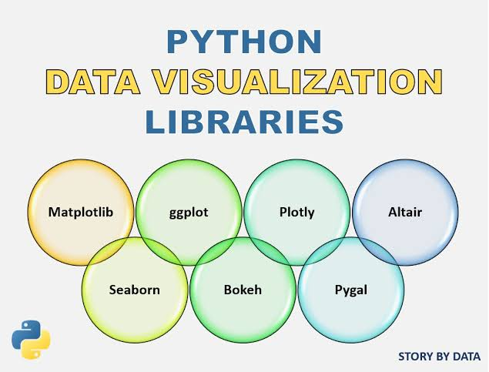

**Objective**:

To Create a comprehensive documentation guide for 2 Python visualization libraries: Matplotlib and Seaborn

BY:

AMISHA KUMARI

DATA SCIENCE

SRM UNIVERSITY, CHENNAI

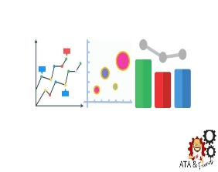 **Table of Contents**

1. Introduction

2. Matplotlib Overview

- Basic Features

- Graph Types

- Line Plot

- Bar Chart

- Histogram

- Scatter Plot

- Pie Chart

- Practical Examples

3. Seaborn Overview

- Basic Features

- Graph Types

- Scatter Plot

- Box Plot

- Heatmap

- Violin Plot

- Pair Plot

- Practical Examples

4. Library Comparison

- Ease of Use

- Customization

- Interactivity

- Performance

5. Conclusion

**INTRODUCTION**

Data visualization is a crucial aspect of data analysis and communication, providing an effective way to represent data insights in a visually comprehensible form. When working with large datasets, it becomes difficult to identify patterns, trends, or outliers merely by looking at the raw data. Visualization bridges this gap, making data interpretation easier by transforming complex numerical or categorical information into easy-to-understand visual representations .Data visualization is not just about generating attractive graphs or charts; it’s about presenting data in a way that is understandable and useful. As the saying goes, "A picture is worth a thousand words," and when it comes to data, visual representations can often convey insights far better than a table full of numbers .In the world of Python, two libraries that excel in data visualization are Matplotlib and Seaborn. They cater to different levels of user expertise, and both offer powerful tools to create meaningful visualizations.

Matplotlib is one of the oldest and most widely used Python libraries for data visualization. It was originally developed by John D. Hunter in 2003 as a way to create plots in Python with the look and feel of MATLAB, a proprietary programming language commonly used for data analysis. Matplotlib has since become the foundation of most Python visualization libraries, providing users with a flexible and powerful tool for generating a wide variety of plots.

Matplotlib's ability to generate all these plots with relatively straightforward syntax has made it an indispensable tool for data visualization. While Matplotlib provides a solid foundation for data visualization, it can sometimes be cumbersome for users who are looking for simpler and more elegant ways to create attractive visualizations. Seaborn was built to address these concerns, offering a higher-level interface for creating visually appealing and informative statistical plots.

Developed by Michael Waskom, Seaborn builds on top of Matplotlib, simplifying many of the repetitive tasks required for creating common plots while adding powerful new features tailored for statistical analysis . Seaborn’s ability to streamline the process of creating complex statistical plots has made it a favourite among data scientists and analysts .In practice, many users opt to use both libraries in tandem. They use Matplotlib for custom visualizations that require fine-tuning and Seaborn for quickly generating polished, statistical plots.

In Conclusion ,both Matplotlib and Seaborn play an essential role in the Python data visualization ecosystem. Matplotlib, with its flexibility and extensive customization options, is a powerful tool for creating a wide variety of plots. Seaborn, on the other hand, simplifies the process of creating beautiful, statistically-informed visualizations. Together, these libraries form the foundation of most data visualization workflows in Python, allowing users to communicate their data insights effectively.

**Matplotlib Overview**

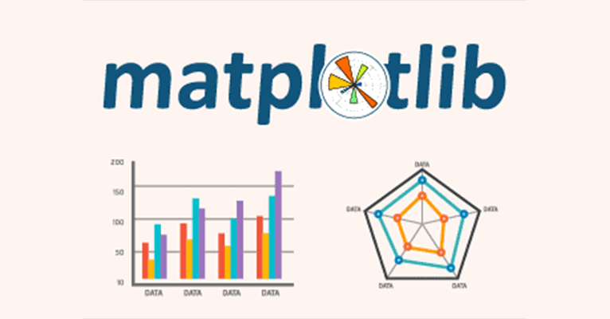

Matplotlib is one of the most popular and versatile data visualization libraries in Python. Created by John D. Hunter in 2003, Matplotlib provides users with the ability to generate a variety of static, interactive, and animated plots, making it suitable for a range of data visualization needs—from exploratory data analysis to publication-quality figures.

**Key Features of Matplotlib**:

- Flexibility: Matplotlib allows users to create almost any kind of plot, from basic line charts to advanced 3D plots.

- Customization: Nearly every element of a Matplotlib figure can be customized, including labels, colors, line styles, and more.

- Integration: Matplotlib works seamlessly with other libraries such as NumPy and Pandas, making it ideal for scientific computing and data analysis workflows.

- Output Formats: Matplotlib supports multiple output formats (PNG, PDF, SVG), allowing for high-quality export suitable for publications and presentations.

**Basic Structure of a Matplotlib Plot**:

Before diving into specific types of plots, it's essential to understand the anatomy of a Matplotlib figure. A typical plot in Matplotlib consists of several key components:

1. Figure: The overall container that holds everything in the plot.

2. Axes: The area where the data is plotted. A figure can have multiple axes.

3. Title: The heading for the figure or individual axes.

4. Legend: Explains what the different colors or markers represent.

5. Ticks and Labels: Indicate the values along the x- and y-axes.

6. Gridlines: Optional lines that make it easier to read the graph.

**Common Graph Types in Matplotlib**:

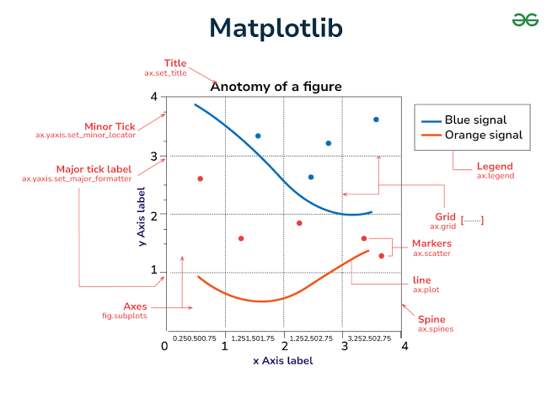

Matplotlib offers a wide range of graph types, each with unique advantages for different types of data analysis and visualization. Below are the most commonly used plots:

3.1 **Line Plot**

A line plot is the most straightforward plot in Matplotlib and is often used to display trends over time.

- Use Case: Track changes over intervals of time or continuous variables.

- Code Example:

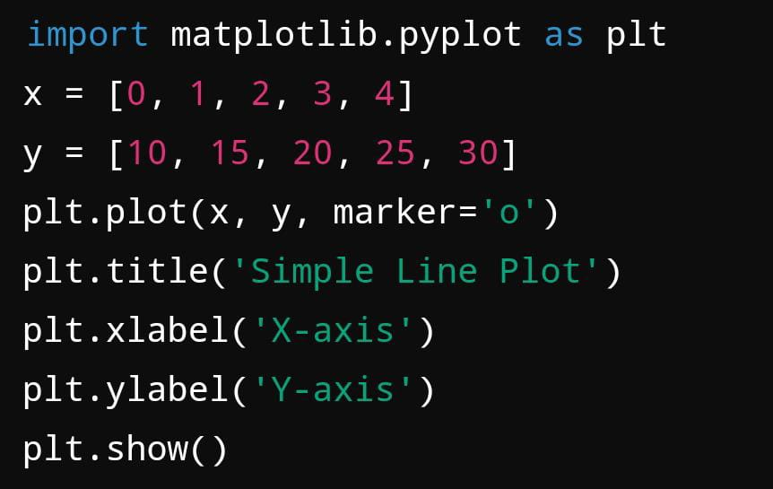

3.2 **Bar Chart**

A bar chart is used to display categorical data with rectangular bars, where the length of the bars represents the values.

- Use Case: Comparing different categories or groups.

- Code Example:

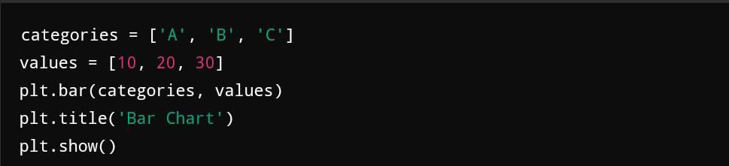

3.3 **Scatter Plot**

A scatter plot represents the relationship between two variables by displaying points on a 2D plane. Each point represents an observation.

- Use Case: Showing relationships, patterns, or correlations between two continuous variables.

- Code Example:

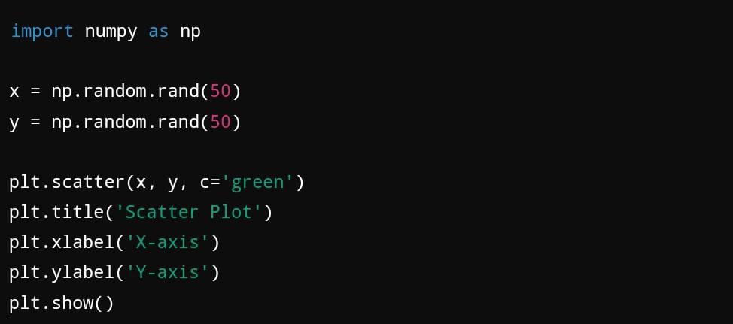3.4

3.4 **Histogram**

A histogram is a representation of the distribution of numerical data, where the data is divided into bins or intervals.

- Use Case: Display the distribution or frequency of values in a dataset.

- Code Example:

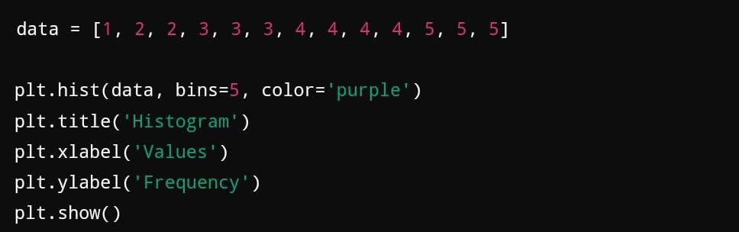

3.5 **Pie Chart**

A pie chart is used to represent proportions or percentages of a whole. Each wedge of the pie represents a category.

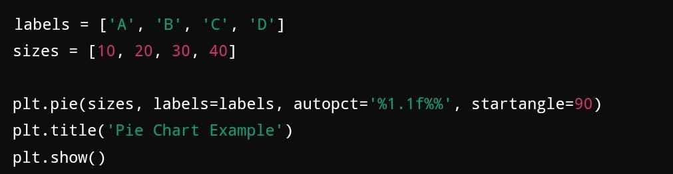

**Advanced Plotting with Matplotlib**

In addition to basic plots, Matplotlib also supports more advanced visualizations such as 3D plots and subplots.

4.1 **Subplots**

Subplots allow users to display multiple plots in a single figure.

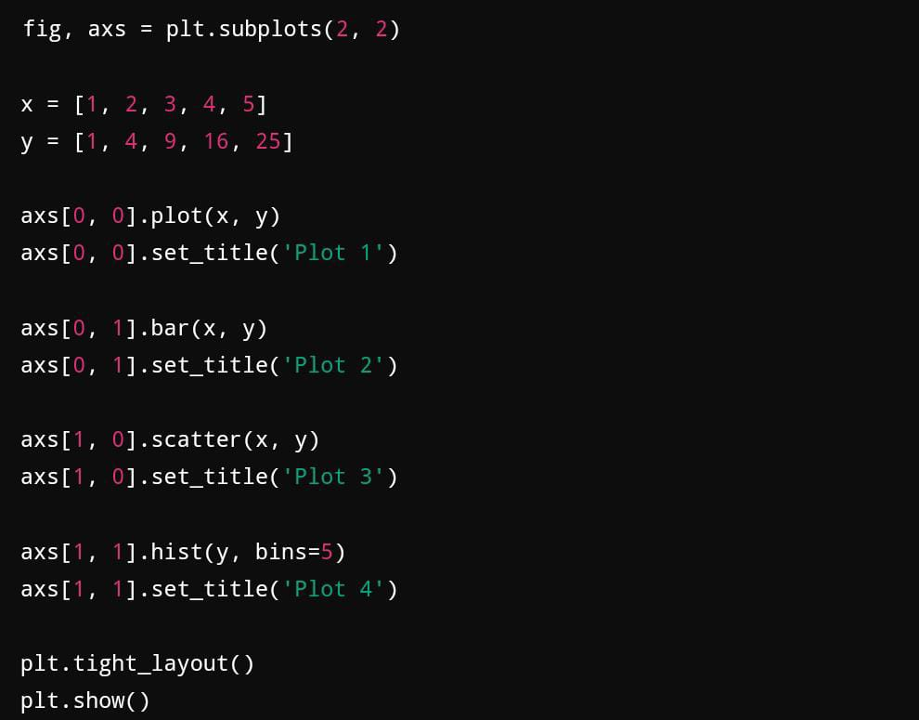

4.2 **3D Plotting**

Matplotlib also allows for 3D plotting, which can be useful in scientific and mathematical contexts.

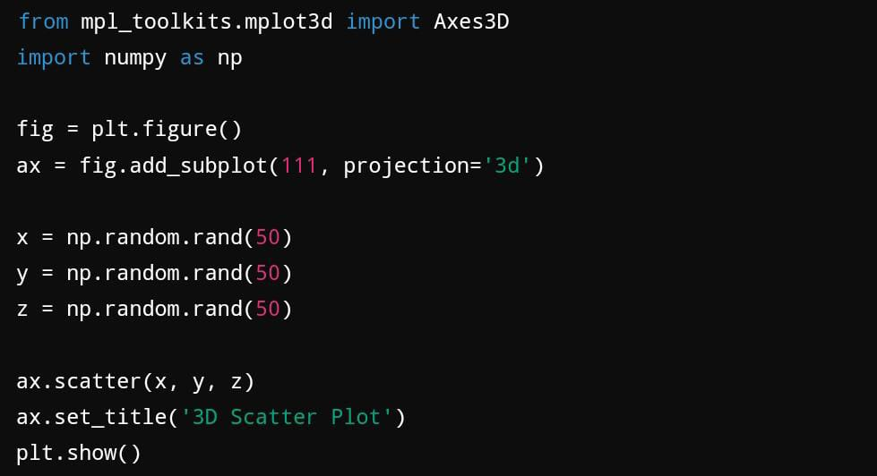

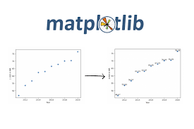

**Customizing Matplotlib Plots**

Matplotlib provides extensive options to customize every aspect of a plot, from titles and labels to colors and line styles. Some of the key customization options include:

- Colors: Customizing the color of plot elements (e.g., lines, bars).

- Line Styles: Changing the line style (e.g., dashed, dotted) or width.

- Labels and Titles: Adding meaningful labels to axes and titles to plots.

- Annotations: Adding text annotations to specific data points for clarity.

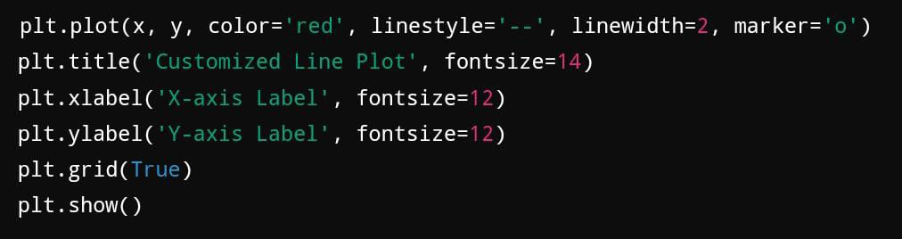

In conclusion, **Matplotlib** remains one of the most powerful and flexible libraries for creating visualizations in Python. Whether you need a simple line plot or an advanced 3D scatter plot, Matplotlib offers the tools necessary to create high-quality, customizable figures. Its versatility and integration with other Python libraries make it an essential part of any data analyst or scientist's toolkit.

**Seaborn Overview**



Seaborn is a high-level Python visualization library built on top of Matplotlib, designed specifically for making complex statistical plots simpler to create. Seaborn helps data scientists visualize distributions and relationships in data, adding powerful features for handling datasets, drawing attractive graphs, and reducing the code needed to generate sophisticated visualizations.

**Key Features of Seaborn**:

- Simplified Syntax: Seaborn's functions abstract away many of the complexities of Matplotlib, making it easier to generate high-quality plots with less code.

- Built-in Themes: Seaborn provides several aesthetic themes for visualizations that are automatically applied to plots, giving them a polished appearance by default.

- Data Handling: Seamless integration with Pandas, allowing users to easily pass DataFrames and work with column names directly.

- Statistical Plots: Seaborn comes with built-in functions for creating complex statistical visualizations like regression plots and heatmaps.

**Basic Structure of a Seaborn Plot**

Similar to Matplotlib, Seaborn plots follow a basic structure but with more simplified syntax, which reduces boilerplate code. At its core, Seaborn still relies on Matplotlib’s plotting framework but adds powerful defaults and streamlined workflows for better data handling.

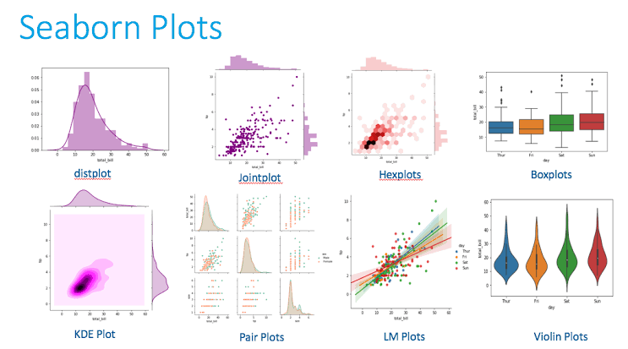

Basic Syntax Example:

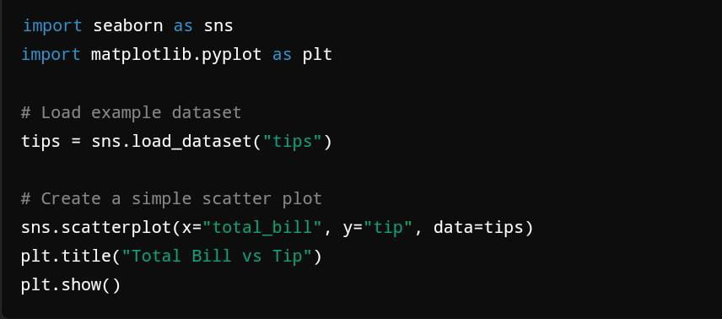

**Common Graph Types in Seaborn**

Seaborn offers a rich selection of plot types that cater to various needs, particularly for statistical analysis. Some of the most commonly used plot types are listed below, each accompanied by a code snippet and example.

3.1 **Scatter Plot**

Seaborn’s scatter plot is highly customizable and supports additional features like automatic categorization and coloring by group.

- Use Case: Displaying relationships between two continuous variables, often with group distinctions.

- Code Example:

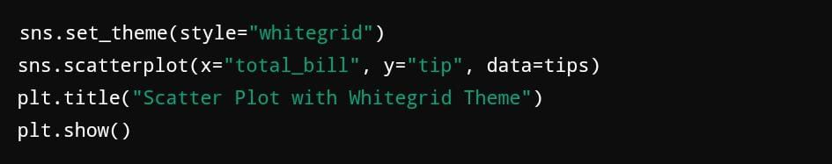

3.2 **Line Plot**

A line plot is used to visualize trends or changes over time. Seaborn’s line plot is optimized for time-series data and can easily incorporate statistical estimations.

- Use Case: Tracking changes in data points over time or across categories.

- Code Example:

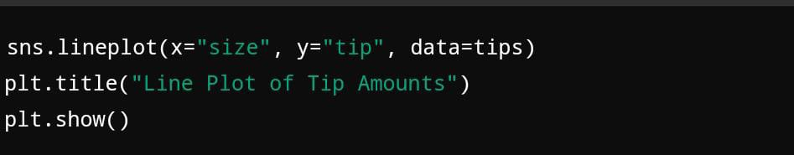

**3.3 Bar Plot**

A bar plot in Seaborn is useful for comparing categorical data, with the added functionality of plotting confidence intervals by default.

- Use Case: Comparing the average values across different categories or groups.

- Code Example:

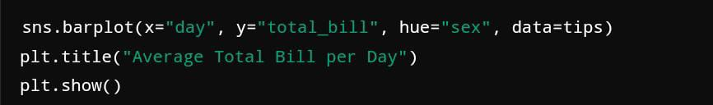

3.4 **Box Plot**

The box plot displays the distribution of a dataset based on a five-number summary (minimum, first quartile, median, third quartile, and maximum), highlighting outliers.

- Use Case: Understanding the spread and skewness of data distributions.

- Code Example:

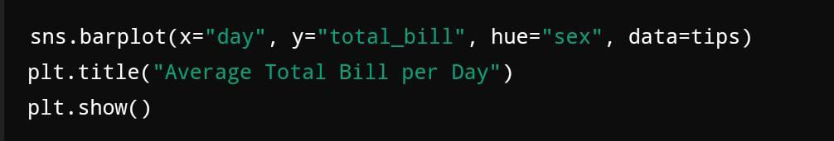

3.5 **Violin Plot**

A violin plot is a combination of a box plot and a density plot. It provides additional insight into the distribution of the data beyond the summary statistics.

- Use Case: Showing the full distribution of the data along with its density.

- Code Example:

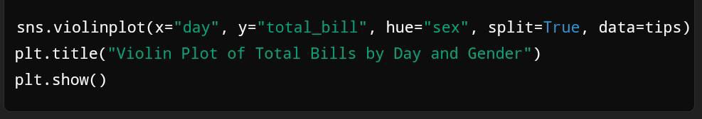

**Advanced Statistical Plots in Seaborn**

Seaborn is particularly powerful for generating complex statistical visualizations with minimal code. Below are some of the more advanced plot types that Seaborn simplifies for users.

4.1 **Heatmap**

A heatmap is a data visualization method that shows matrix-like data using color to represent values.

- Use Case: Analyzing correlations between variables or visualizing grid-like data.

- Code Example:

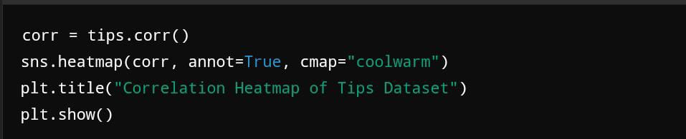

4.2 **Pair Plot**

The pair plot creates a matrix of scatter plots for each pair of variables in the dataset, along with histograms or KDE plots on the diagonals.

- Use Case: Quickly visualizing relationships between multiple variables in a dataset.

- Code Example:

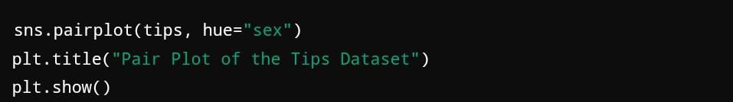

4.3 **Regression Plot (lmplot)**

The regression plot automatically fits and visualizes a regression line through data points, making it useful for trend analysis and correlation assessment.

- Use Case: Determining the linear relationship between variables.

- Code Example:

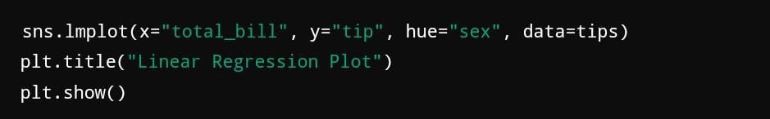

**Customizing Seaborn Plots**

Seaborn provides many options for customizing the appearance of plots, similar to Matplotlib, but with more intuitive defaults. Here are some of the key ways to customize plots in Seaborn:

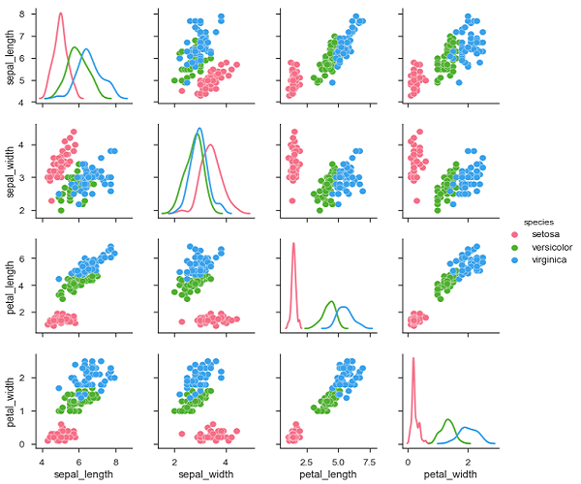

5.1 **Themes**

Seaborn comes with built-in themes to enhance the aesthetics of plots. These themes can be applied globally to all plots.

Code Example:



5.2 **Color Palettes**

Seaborn offers a wide variety of color palettes, including categorical, sequential, and diverging color schemes. Custom palettes can be easily applied to plots.

- Code Example:

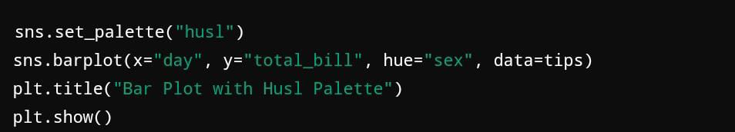

**Library Comparison**

**Ease of Use**

* Matplotlib: Matplotlib is a highly flexible and versatile library, but this flexibility comes at the cost of a steeper learning curve. Generating simple plots requires multiple lines of code, and users must often manually define elements like axes labels, legends, and titles. For beginners, the library can feel overwhelming due to the need for explicit customization, though its extensive documentation helps ease the learning process.
* Seaborn: Seaborn is built on top of Matplotlib, making it easier to use for generating more aesthetically pleasing plots with less code. It is designed for higher-level plotting and integrates smoothly with pandas DataFrames, allowing users to pass entire datasets into the plotting functions. Seaborn also handles many of the aesthetics and statistical elements automatically, which makes it ideal for quick, insightful visualizations during exploratory data analysis.

**Customization**

* Matplotlib: Matplotlib excels in customization. Every component of a plot—axes, ticks, colors, line styles, fonts—can be adjusted to fine detail. It is highly flexible and suited for creating complex, multi-faceted figures that need precise adjustments. While this level of customization is its strength, it can also be time-consuming, especially for simple plots.
* Seaborn: Seaborn abstracts much of the complexity of customizing plots, automatically handling aspects like color schemes, statistical summaries, and figure aesthetics. It has built-in themes and styles that make visualizations look polished with minimal effort. However, if a user requires advanced customization beyond what Seaborn offers, they must often rely on Matplotlib’s lower-level functions, which Seaborn uses under the hood.

**Interactivity**

* Matplotlib: Matplotlib is primarily a static plotting library. While it does support basic interactivity through the use of widgets and external libraries (like mpld3 or ipympl for Jupyter Notebooks), its capabilities for interactivity are limited compared to other libraries like Plotly or Bokeh. If interactive plots are a requirement, users often need to turn to more specialized libraries.
* Seaborn: Seaborn, like Matplotlib, is mostly used for static plots. While it is excellent for generating visualizations that offer quick insights into the data, it lacks native support for interactive elements. Users looking for interactivity in their visualizations will have to incorporate other libraries such as Plotly or Bokeh.

**Performance**

* Matplotlib: Matplotlib is generally efficient for small to moderately large datasets, but its performance can slow down when working with very large datasets, particularly when creating complex figures with many subplots. While it can handle heavy computations, its performance depends heavily on how efficiently the code is written.
* Seaborn: Seaborn is typically fast when generating plots, especially since it is designed for higher-level statistical visualizations. It works well with medium-sized datasets, but for larger datasets, performance issues may arise. As Seaborn is built on Matplotlib, its performance is generally similar, although it is slightly optimized for quick, exploratory visualizations. For very large datasets, using dedicated libraries for big data or sampling smaller chunks of data is often necessary.

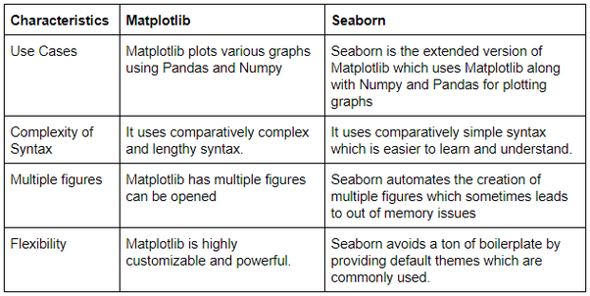

**CONCLUSION**

In this guide, we’ve explored two of the most powerful Python data visualization libraries—Matplotlib and Seaborn—by breaking down their unique features, the types of graphs they offer, and practical examples for creating these visualizations. Both libraries serve as essential tools for any data analyst, scientist, or engineer working with Python, but they cater to slightly different needs and levels of complexity.

**Matplotlib**, the foundational visualization library in Python, is known for its versatility and control. As a low-level library, it offers an extensive set of options for customizing every element of a graph, from the axes and ticks to colors and labels. For users who require precision, Matplotlib’s granular control over plot appearance makes it the go-to tool for creating publication-ready figures. It can generate almost any type of visualization, including line plots, bar charts, histograms, scatter plots, and more.One of Matplotlib’s greatest strengths lies in its flexibility. Whether you need to create a simple scatter plot or a highly customized figure with multiple subplots, Matplotlib provides all the tools to do so. This flexibility is particularly beneficial in scientific research, where precise control over the layout and appearance of plots is critical. Additionally, Matplotlib supports integration with a wide

While Matplotlib ,is an all-purpose tool for data visualization, **Seaborn** simplifies the process of creating aesthetically pleasing and statistically informative graphs. Built on top of Matplotlib, Seaborn abstracts many of the complexities of visualizing data, offering higher-level functions that automatically take care of aesthetics, color palettes, and statistical summaries. Seaborn is especially well-suited for exploratory data analysis (EDA), where users need to quickly generate plots that reveal insights about their datasets.One of Seaborn's key advantages is its seamless integration with Pandas, which allows users to pass DataFrames directly into plotting functions. This not only makes the code more concise but also leverages Pandas' powerful data manipulation capabilities. The ability to work with column names directly and group data automatically is a huge time-saver, allowing users to focus on interpreting the results rather than writing boilerplate code.

By understanding the strengths and weaknesses of these two libraries, users can make informed decisions about which tool to use based on their specific project requirements. Whether you’re creating simple line plots, conducting exploratory analysis, or building complex multi-panel figures, mastering both Matplotlib and Seaborn will undoubtedly enhance your ability to visualize data effectively.

In conclusion, the combination of Matplotlib's flexibility and Seaborn's simplicity provides a comprehensive toolkit for any data visualization task, enabling users to move from initial data exploration to polished final presentations with ease.